Activity no. 6.1 Function
Hands-on Activity 6.1:Function
Course Code: CPE007 | Program: Computer Engineering
Course Title: Programming Logic and Design | Date Performed: 10/16/25
Section: CPE11S1 | Date Submitted:10/23/25
Name(s): Nieles, Cenndy M. | Instructor: Engr. Jimlord M. Quejado
6. Output
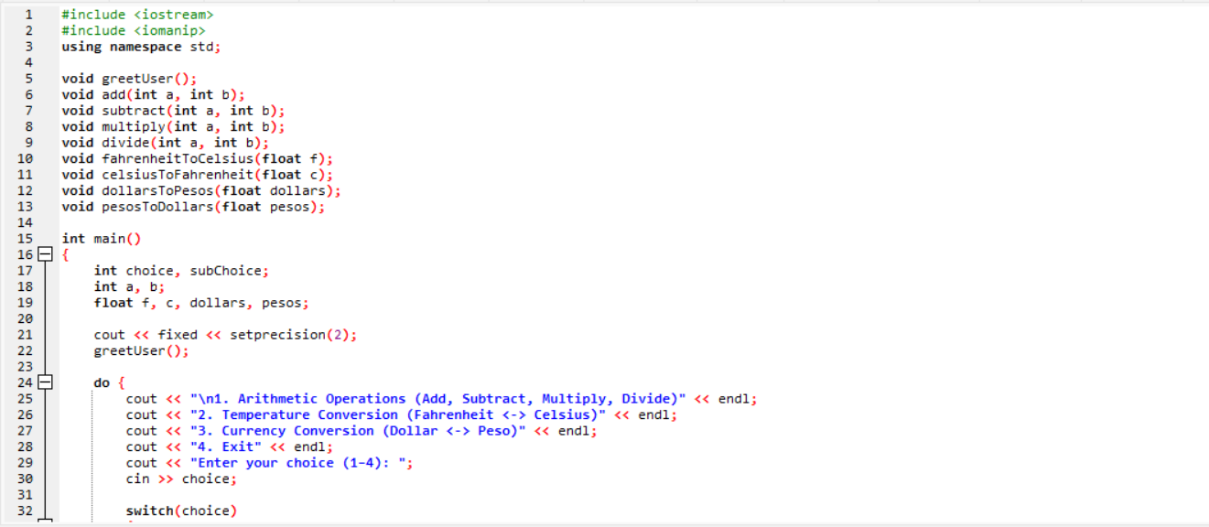

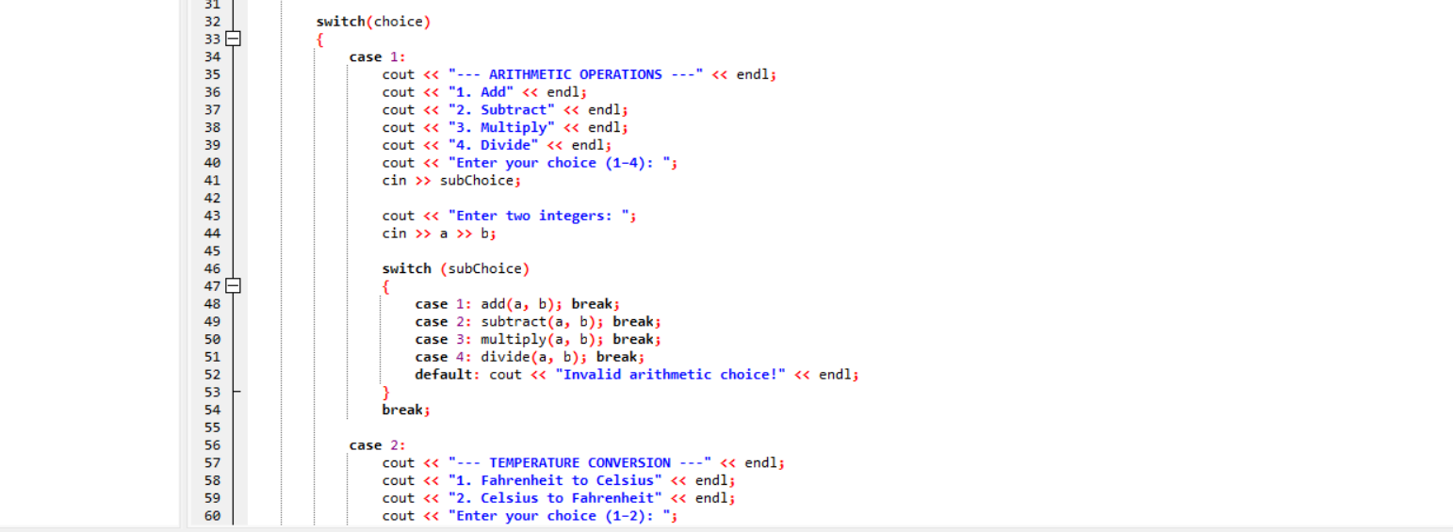

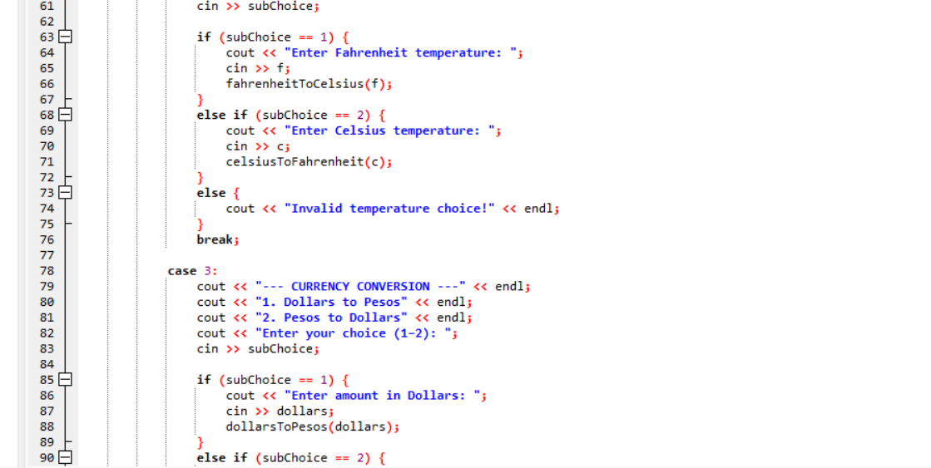

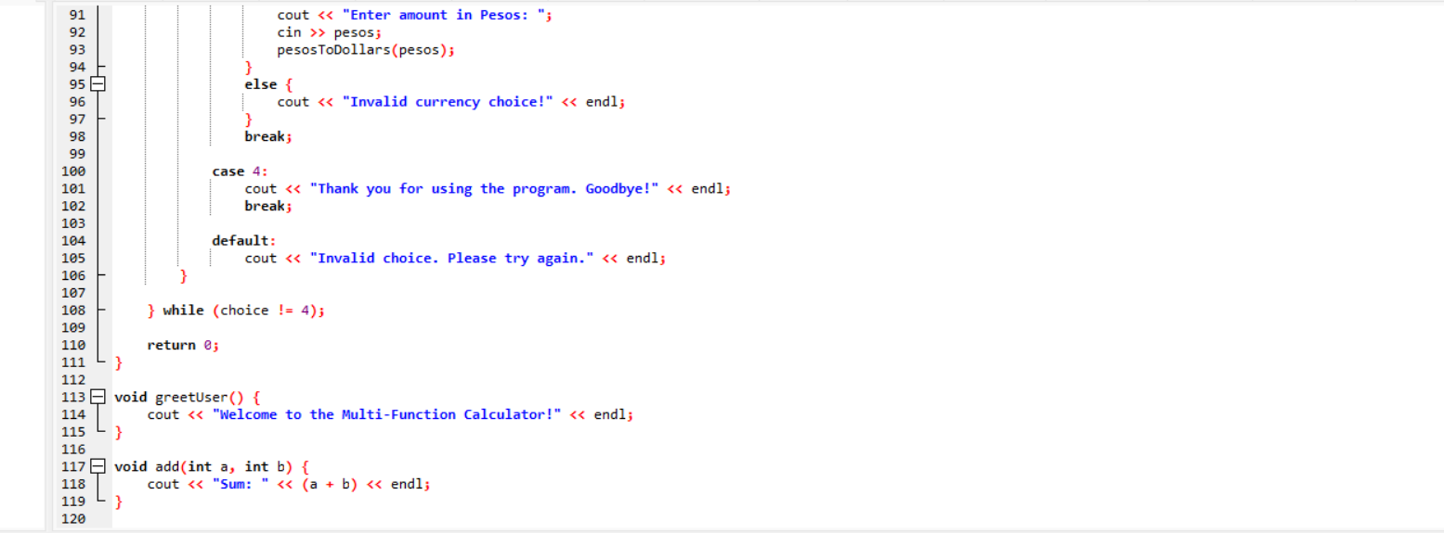

7. Supplementary Activity
This program is a menu-driven multi-function calculator written in C++. It performs arithmetic operations, temperature conversions, and currency conversions between dollars and pesos. The program begins by displaying a welcome message and runs in a continuous loop until the user chooses to exit. Inside the loop, the program presents a main menu with four options: arithmetic operations, temperature conversion, currency conversion, and exit. Each main menu choice leads to a corresponding submenu where the user can select a specific operation.

For arithmetic operations, the program allows the user to add, subtract, multiply, or divide two integers. The divide function includes a check to prevent division by zero. For temperature conversions, the user can convert Fahrenheit to Celsius or Celsius to Fahrenheit using standard formulas. In the currency conversion section, the program converts dollars to pesos or pesos to dollars using a fixed exchange rate of 1 USD = 58.46 PHP. Each operation is handled by a separate function, making the code modular and easy to maintain.

The program uses the fixed and setprecision(2) manipulators to format floating-point numbers with two decimal places, ensuring clear and consistent output. The use of a do-while loop allows the program to continue running until the user explicitly selects the exit option. However, the program does not handle invalid non-numeric input, which could cause input errors. Another limitation is the hardcoded exchange rate, which would need manual updating. Despite these minor issues, the overall structure is clean and well-organized. It demonstrates good use of modular programming and control flow, making it a solid example of a structured beginner-level C++ program.

8. Conclusion
The multi-function calculator program demonstrates a well-structured and modular approach to problem-solving using C++. It combines arithmetic, temperature, and currency conversions in one interactive menu-driven system. Each task is separated into dedicated functions, improving readability and maintainability. The use of loops allows repeated use without restarting the program, and formatted output enhances clarity. The program efficiently applies fundamental programming concepts such as conditionals, loops, user input handling, and mathematical operations. Although it could be improved by adding input validation and dynamic exchange rates, it effectively achieves its purpose as a beginner-friendly project that showcases structured programming and user interaction in C++.

